**Report on preliminary EMMPOWER analysis – March 2011**

Steffi Schäfer & Beth Purse

**Overall data availability, species composition and correlations between species**

We analysed the data from 2010 since these were already in good order and Mick recorded all the vegetation in this year. Five species were caught in larval dips (Table 1). *Culex pipiens* and *Culiseta annulata* were the dominant species, making up 53% and 44% of all individuals trapped respectively. Out of the seasonal snapshots, the largest proportion of the mosquito population as a whole was trapped in August/September. For the anophelines, most individuals were caught in June/July.

Table 1. Total abundance and proportional abundance of five mosquito species caught in larval dips in 2010. Season 1 = May; Season 2 = June/July; Season 3 = August/September

|  |  |  |  |  |  |  |  |
| --- | --- | --- | --- | --- | --- | --- | --- |
| Species | All seasons | Season 1 | | Season 2 | | Season 3 | |
| Sum (%) | Sum(%) | | Sum (%) | | Sum (%) | |
| *An. maculipennis* | 65 (1.2) | 4 (5.4) | | 39 (2.4) | | 22 (0.6) | |
| *Cx. pipiens* | 2820 (52.6) | 33 (44.6) | | 407 (25.0) | | 2380 (65.1) | |
| *An. claviger* | 96 (1.8) | 2 (2.7) | | 55 (3.4) | | 39 (1.1) | |
| *Cs. annulata* | 2374 (44.3) | 35 (47.3) | | 1126 (69.2) | | 1213 (33.2) | |
| *O. caspius* | 2 (0.0) | 0 (0.0) | | 0 (0.0) | | 2 (0.1) | |
| Total | 5357 | | 74 | | 1627 | | 3656 | |

In 2010, there were 366 dip-points sampled in total (excluding those that had dried out) in 67 plots. Examining the occurrence of species across dip-points and plots, it can be seen that the data are very sparse. Even the dominant mosquitoes, *Cx. pipiens* and *Cs. annulata* are only present in 11% and 7% of dip-points respectively in season 3 for example (Table 2). At the plot level, across all seasons, *An. maculipennis* is most widespread, being present in around one third of plots - despite making up a low proportion of the total mosquitoes caught. *Cx. pipiens* and *An. claviger* are present in around a quarter of plots whilst *Cs. annulata* is present in 16% of plots.

Table 2. Occurrence of five mosquito species caught in larval dips in 2010 summarised at the dip-point and plot levels (out of 366 dip-points and 67 plots)

|  |  |  |  |  |  |  |  |  |
| --- | --- | --- | --- | --- | --- | --- | --- | --- |
| Species | No. of dips (is it dip points or dips?) in which species is present | | | | No. of plots in which species is present | | | |
| All seasons | season 1 | season 2 | season 3 | All seasons | season 1 | season 2 | season 3 |
| *An. maculipennis* | 46 | 4 | 24 | 18 | 24 | 3 | 16 | 11 |
| *Cx. pipiens* | 55 | 7 | 6 | 42 | 15 | 3 | 2 | 12 |
| *An. claviger* | 25 | 1 | 10 | 14 | 15 | 1 | 7 | 8 |
| *Cs. annulata* | 49 | 10 | 10 | 29 | 11 | 5 | 4 | 8 |
| *O. caspius* | 1 | 0 | 0 | 1 | 1 | 0 | 0 | 1 |

Due to the sparseness of the data, it was felt to be most appropriate when analysing the relationship between environmental factors and species distributions to amalgamate the data at the plot level and to use statistical approaches such as zero-inflated GLM models. Otherwise to make a model at the dip point level, we would be contrasting for example for *An. claviger* 25 dip-points across the seasons with the species, with 1072 (1097-25) dip-points without the species.

The problem with summarising the data at the plot level is that, due to the randomisation of proximal, central and distal dipping each plot was not subject to the same sampling effort. In order for this to be the case, the same number of proximal, central and distal dips (or at least edge and centre dips) would have had to have been taken in each plot. For this preliminary analysis, we ignored these issues and summed the mosquito data per plot. For the final analysis, we may need to subset the data to ensure that plots had the same number of edge and central dips each.

Fig. S1 shows the distribution of *An. maculipennis, Cx. pipiens, An. claviger*, and *Cs. annulata* across plots in each season. In fact the distributions of *An. claviger, Cx. pipiens,* and *Cs. annulata* are quite highly correlated with each other (An. clav X Cs. ann; r=0.565, p < 0.0001; Cs. ann x Cx. pip; r=0.698, p <0.001; Cx. pip X An. clav; r=0.527, p < 0.0001) whilst the distribution of *An. maculipennis* is weakly correlated with those of the other species (An. mac X Cs. ann; r=-0.114, p=0.356; An. mac X Cx. pip; r=-0.219, p=0.07; An. mac X An. clav; r=-0.022, p=0.858).

**Correspondence between adult and larval mosquito communities**

We discussed how some species were found in adult traps but never in larval dips. For example, Coquillettidia richiardii larvae are anchored to plant surfaces rather than being in the water column or the water surface. Suggest we assign each adult trap to its nearest larval plot and compare the species composition between life stages (multinomial model and/or chi-squared).

**Environmental variables: processing, seasonal variation and missing factors**

Initial correlations between mosquito species and values of environmental variables at the plot level are reported in Vector_dataset_summary.xlsx but need to be re-evaluated when the relationships between environmental variables has been more fully explored (e.g. using PCA/CCA).

**Water Chemistry**

pH values flagged as dodgy were deleted. Values of other variables were averaged across the rhyne. pH and oxygen were found to be significantly higher in plots in season 1 compared to season 2 and 3. Beth, we did discuss that this is most likely to a higher temperature in the later seasons, didn’t we? I cannot seem to find anything on temp in the table below. Is that an oversight or deliberate? There were no significant seasonal differences in turbidity and salinity between seasons.

Table 3. Means of water chemistry parameters in each plot in each season together with results of

Wilcoxon signed rank tests for seasonal differences.

|  |  |  |  |  |  |  |  |  |  |
| --- | --- | --- | --- | --- | --- | --- | --- | --- | --- |
| Seasonal  means | 1 | 2 | 3 | W  1 v 2 | p | W  2 v 3 | p | W  3 v 2 | p |
| Turbidity | 0.595 | 0.565 | 0.580 | 838 | 0.93 | 816 | 0.89 | 991 | 0.92 |
| Salinity | 0.439 | 0.428 | 0.446 | 817.5 | 0.88 | 795.5 | 0.83 | 970 | 0.97 |
| Dissolved oxygen | 167.6 | 121.2 | 127.7 | 1641 | <0.0001 | 1233.5 | <0.0001 | 1934 | <0.0001 |
| ph | 7.34 | 6.93 | 7.09 | 1121.5 | 0.019 | 936.5 | 0.164 | 1293.5 | 0.026 |

Initial correlations:

* An. claviger associated with high turbity and salinity
* An. claviger, Cs. annulata, Cx. pipiens all negatively correlated with pH
* An. maculipennis negatively associated with dissolved oxygen
* An. claviger and Cs. annulata positively associated with dissolved oxygen

**Rhyne management**

Rhyne dip points were scored as dry in particular seasons and it was also scored whether the rhyne was dry in any season. At the plot level, it was recorded (Yes or No) if the plot was dry ever, in which seasons it was wet and the number of wet seasons overall. Similarly for rhyne clearance at the plot level, it was scored whether the rhyne had been cleared between seasons. For rhyne exposure, the proportion of open dip points per plot was scored in each season (treating partial shade and shade as equivalent) and then this was averaged across seasons.

Beth, do I understand this right: did you average the percentage shade per dip point over the whole three seasons? Or for each season averaged the shade of the indidual dip points to get a plot-specific seasonal average? I am only asking because shade from emergent vegetation in spring will be lower than later in the year.

Initial correlations:

* Cx. pipiens positively correlated with rhyne clearance
* An. claviger, Cs. annulata, Cx. pipiens all negatively correlated with rhyne openess
* An. maculipennis weakly positively correlated with rhyne openness

**Rhyne morphology**

Some missing values in rhyne width filled in with 2009 values or using photographs. Flow data were not used in this version of the analysis. Water depth (proximal and central) was averaged across the dip points in a plot. Tier 3 rhynes seem to be quite a lot deeper in spring than in summer and autumn whilst there is less variation in depth year round in Tier 1 plots (Table 4). The depth of the water below land (or freeboard) is higher in Tier 1 plots as expected.

Table 4. Average rhyne morphology variables across plots in each season for all plots, tier 1 plots and tier 3 plots.

|  |  |  |  |  |  |  |  |  |  |
| --- | --- | --- | --- | --- | --- | --- | --- | --- | --- |
| Morphology  variable | ALL SITES | | | TIER 1 | | | TIER 3 | | |
| seas1 | seas2 | seas3 | seas1 | seas2 | seas3 | seas1 | seas2 | seas3 |
| width | 2.46 | 2.55 | 2.32 | 2.29 | 2.33 | 2.17 | 2.62 | 2.74 | 2.44 |
| freeboard | 0.53 | 0.55 | 0.53 | 0.73 | 0.73 | 0.67 | 0.35 | 0.43 | 0.42 |
| depth_p | 20.03 | 15.15 | 17.32 | 18.83 | 18.20 | 19.14 | 21.02 | 13.09 | 15.92 |
| depth_c | 53.74 | 48.37 | 48.28 | 41.93 | 49.53 | 49.20 | 63.59 | 47.58 | 47.58 |

Very nice to see difference in freeboard between tier 1 and tier 3. This is exactly how it should be – if memory serves me right the Tier 3 scheme prescribes the freeboard not to fall below 35 cm in summer.

Initial correlations:

* An. claviger, Cs. annulata, Cx. pipiens negatively correlated with rhyne depth
* An. maculipennis positively correlated with rhyne depth
* An. maculipennis negatively correlated with depth below land
* Cs. annulata, Cx. pipiens negatively correlated with rhyne width

**Rhyne vegetation**

As well as looking at how the vegetation communities depend on rhyne characteristics (CCA/PCA), we also decided to separate the plants into functional groups depending on their likely influence on mosquito communities as follows:

1. “Vertical” group includes Carex, Equisetum, Glyceria, Typha, Juncus, Yellow flag, Phragmites
2. “Emergent” group with overhanging/cantileavered foliage includes Water parsnip, Water plantain and Arrowhead
3. “Surface floater” group includes Duckweed, Ivy-leaved Duckweed, Frogbit and Blanketweed

For all these groups, mean of summed cover of constituent species was calculated (by proximal, distal and central) per plot. For group 1, a weighted mean height will also be calculated per plot, with the weights proportional to the species cover.

We found a useful paper of Owen’s that summarises the impacts of channel characteristics on rhyne vegetation (using the same type of ordination analyses we may use).

Mountford, J.O. (2006) The vegetation of artificial drainage channels within grazing marshes in the UK: How does its composition correspond with described communities? Biology and Environment: Proceedings of the Royal Irish Academy 106B, 3, 275-285.

**Predators**

These were summed across dip points in the plot. The most abundant and prevalent predators were fish, water boatmen and water beetles (Table 5). Some initial correlations between mosquitoes and predators are reported in Vector_dataset_summary.xlsx as follows:

* Cs. pipiens, Cs. annulata, An. claviger negatively correlated with water boatmen and damselflies, weaker negative correlations with dragonflies and newts
* Cs. pipiens, Cs. annulata, An. claviger positively correlated with water beetle larvae
* Both anophelines weakly correlated with fish where as culicinae are negatively correlated.
* An. maculipennis positively correlated with damselfly and dragonfly larvae
* An. maculipennis negatively correlated with tadpoles though quite weak effect

Table 1. Total abundance and occurence of key predators caught in larval dips in 2010.

|  |  |  |  |  |  |  |  |  |
| --- | --- | --- | --- | --- | --- | --- | --- | --- |
|  | Summed abundance | | | | Occurrence in plots | | |  |
| Predator | All | Season 1 | Season 2 | Season 3 | All | Season 1 | Season 2 | Season 3 |
| Water.boatman | 592 | 361 | 189 | 42 | 49 | 32 | 36 | 20 |
| Water.beetle | 562 | 246 | 165 | 151 | 62 | 45 | 41 | 43 |
| Fish | 427 | 170 | 203 | 54 | 57 | 39 | 44 | 29 |
| Gammarus | 397 | 149 | 179 | 69 | 42 | 22 | 17 | 21 |
| Damselfly.larva | 294 | 65 | 39 | 190 | 46 | 21 | 17 | 38 |
| Tadpole | 246 | 244 | 2 | 0 | 5 | 5 | 1 | 0 |
| Water.beetle.larva | 158 | 60 | 64 | 34 | 40 | 25 | 16 | 17 |
| Saucer.bug | 74 | 0 | 53 | 21 | 19 | 0 | 12 | 13 |
| Dragonfly.larva | 57 | 34 | 6 | 17 | 22 | 16 | 5 | 5 |
| Newt | 23 | 1 | 13 | 9 | 15 | 1 | 10 | 8 |
| Water.scorpion | 16 | 1 | 11 | 4 | 14 | 1 | 10 | 3 |
| Flatworm | 15 | 12 | 3 | 0 | 6 | 3 | 3 | 0 |
| Backswimmer | 8 | 1 | 6 | 1 | 6 | 1 | 4 | 1 |
| Frog | 3 | 0 | 3 | 0 | 1 | 0 | 1 | 0 |
| Phantom.midge | 2 | 0 | 1 | 1 | 2 | 0 | 1 | 1 |
| Water.spider | 0 | 0 | 0 | 0 | 0 | 0 | 0 | 0 |

**Next steps**

Use ordination analysis to understand relationships between channel environmental factors and vegetation (including tier level) and between vegetation and predators at the plot level. Use this understanding couple with trait information for four target mosquito species to select a priori environmental factors on which their distributions may depend (or use site scores from CCA as summary environmental variables). Model plot level abundance of species using mixed models (possibly zero-inflated) with site as a random factor. Examine whether impacts are consistent between seasons and years.

**Other environmental factors to be added in/by November**

* Water temp (if this is not already done).
* Tier to be clarified with farmers through questionnaires
* Precise timing of rhyne clearance to be clarified with farmers through questionnaires
* Stocking levels to be clarified with farmers through questionnaires
* Drainage management board to be consulted about water flow and hierarchy of rhyne within the draining system etc.
* Derive altitude, wood/forest cover and soil type from GIS
* Owen also scored whether rhynes were adjacent to arable land or roads – we could derive this also from the GIS.
* Consult Owen on functional groupings / results of PCA and CCA

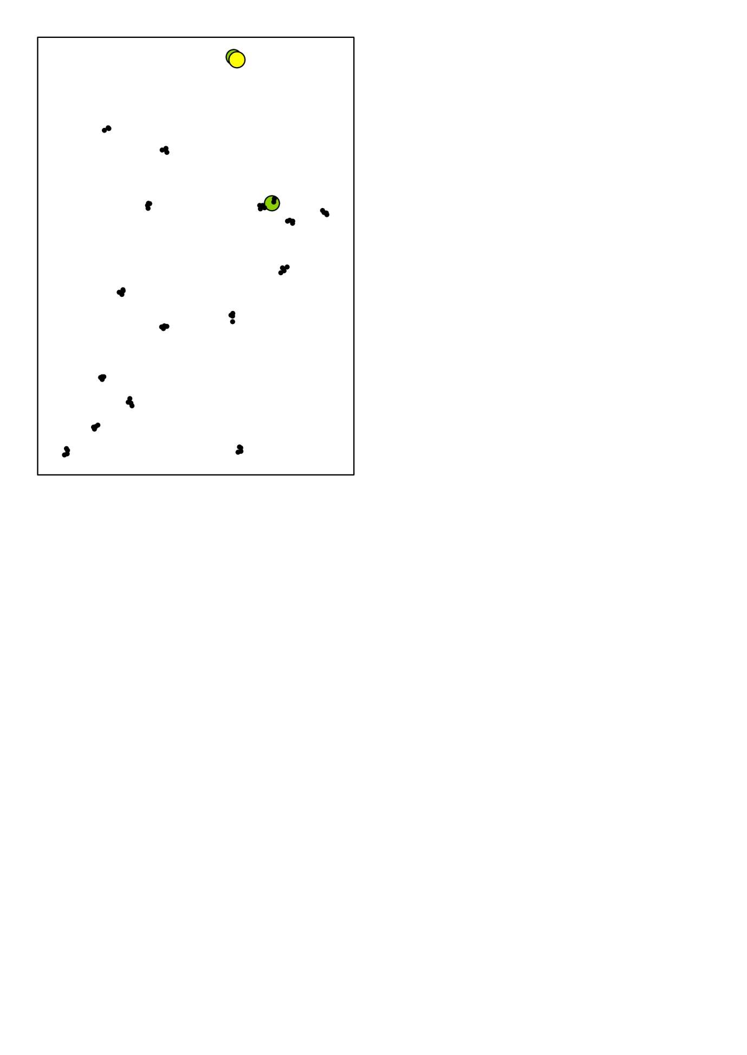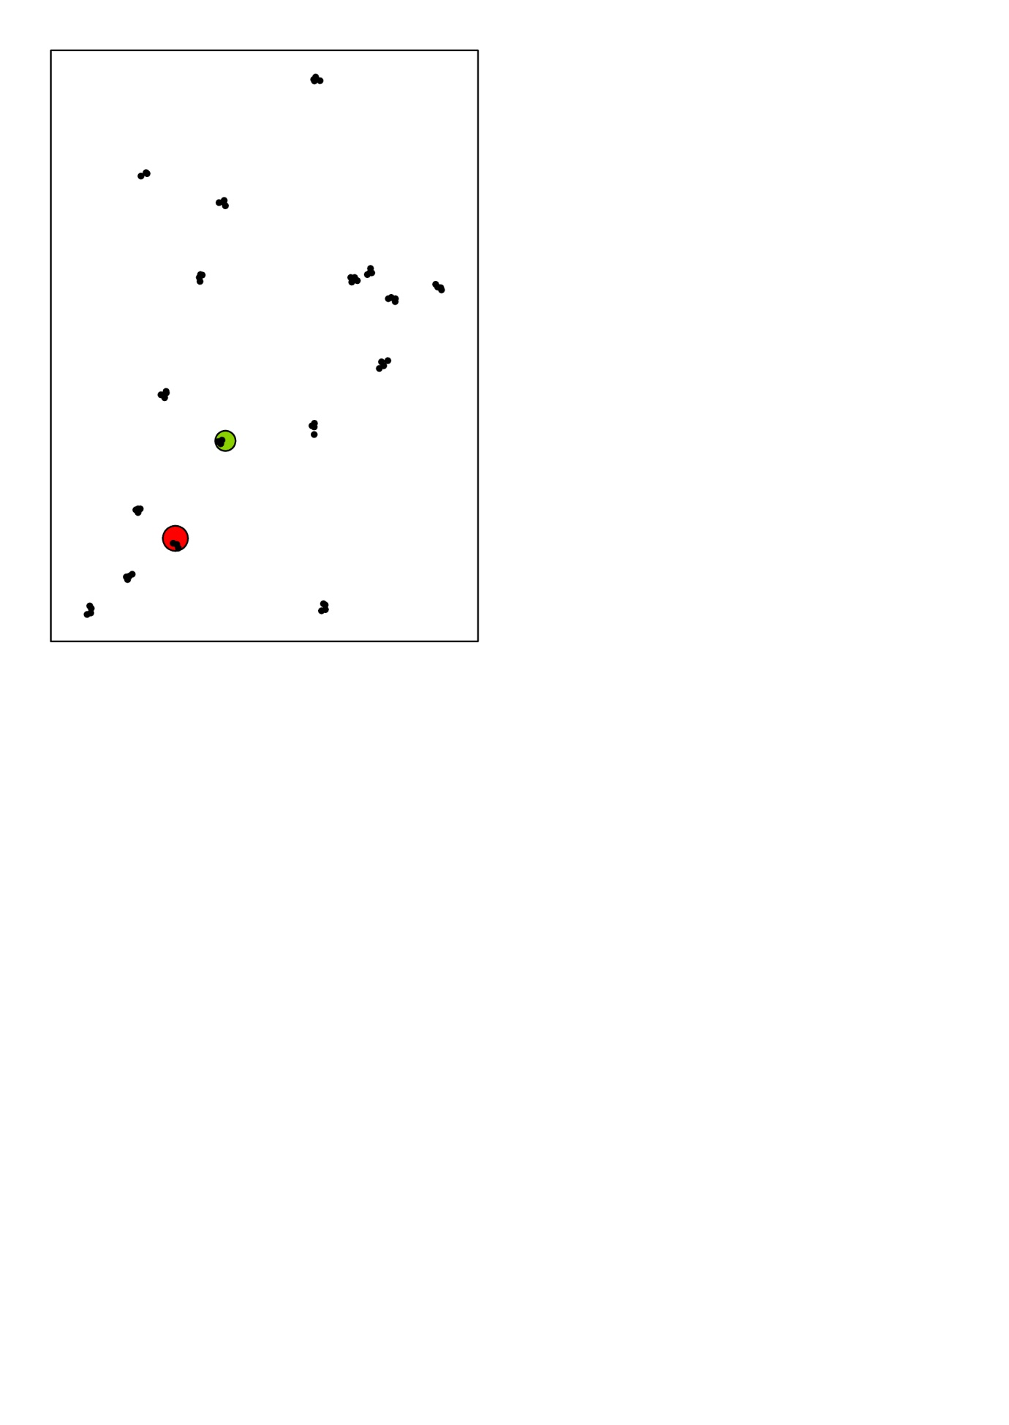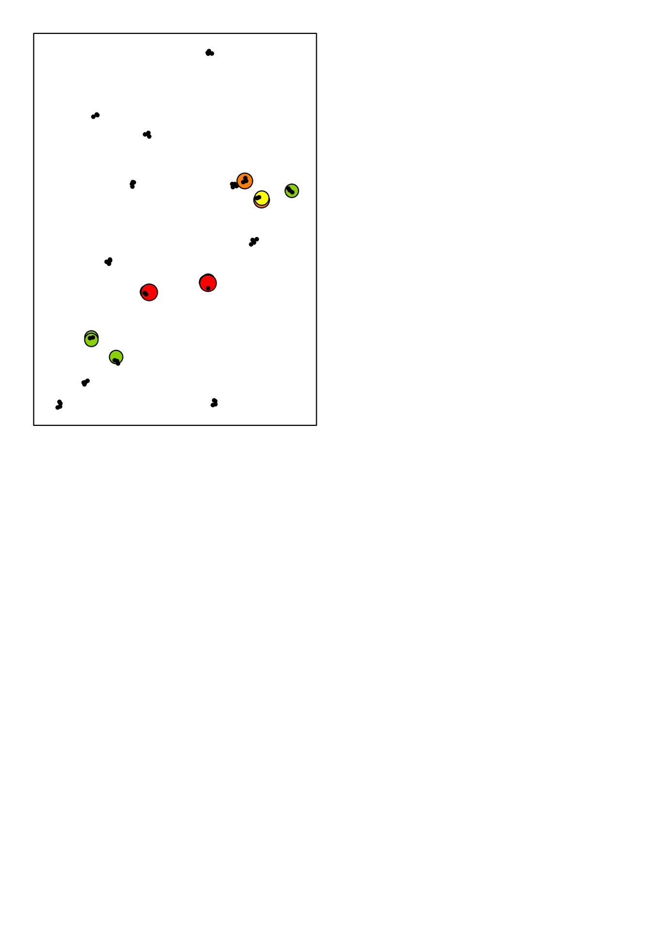

Season 3

Season 2

Season 1

Fig. S1a Distribution of *Cx. pipiens* in each season of 2010. Summed abundance across dip-points per plot.

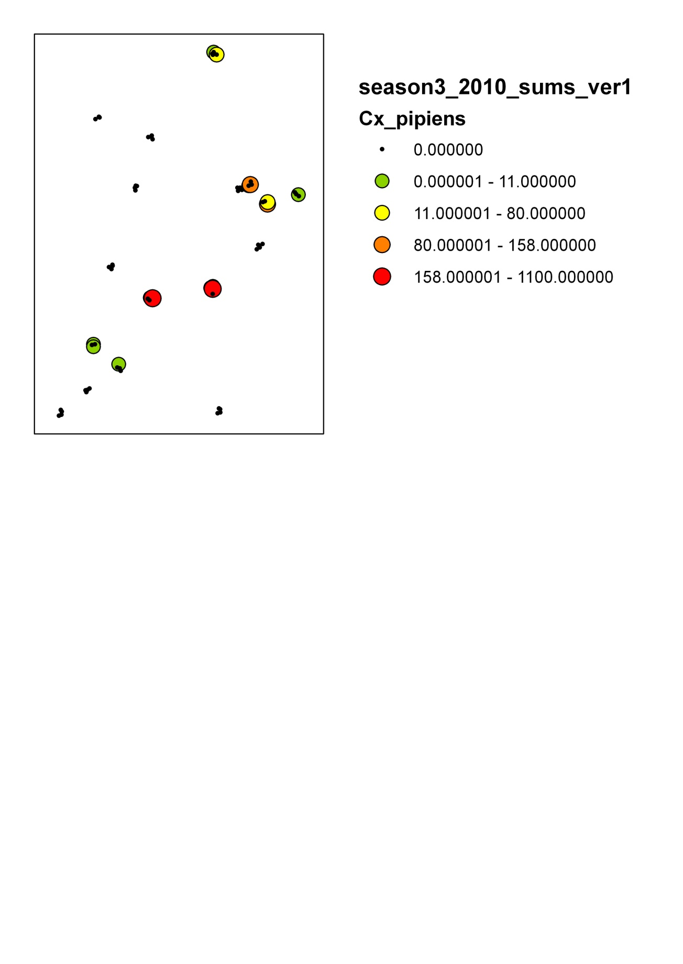

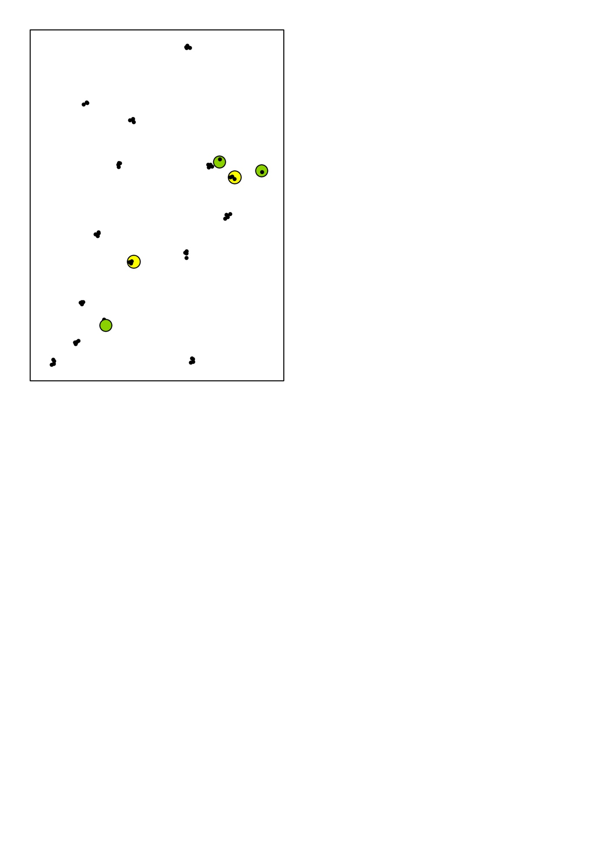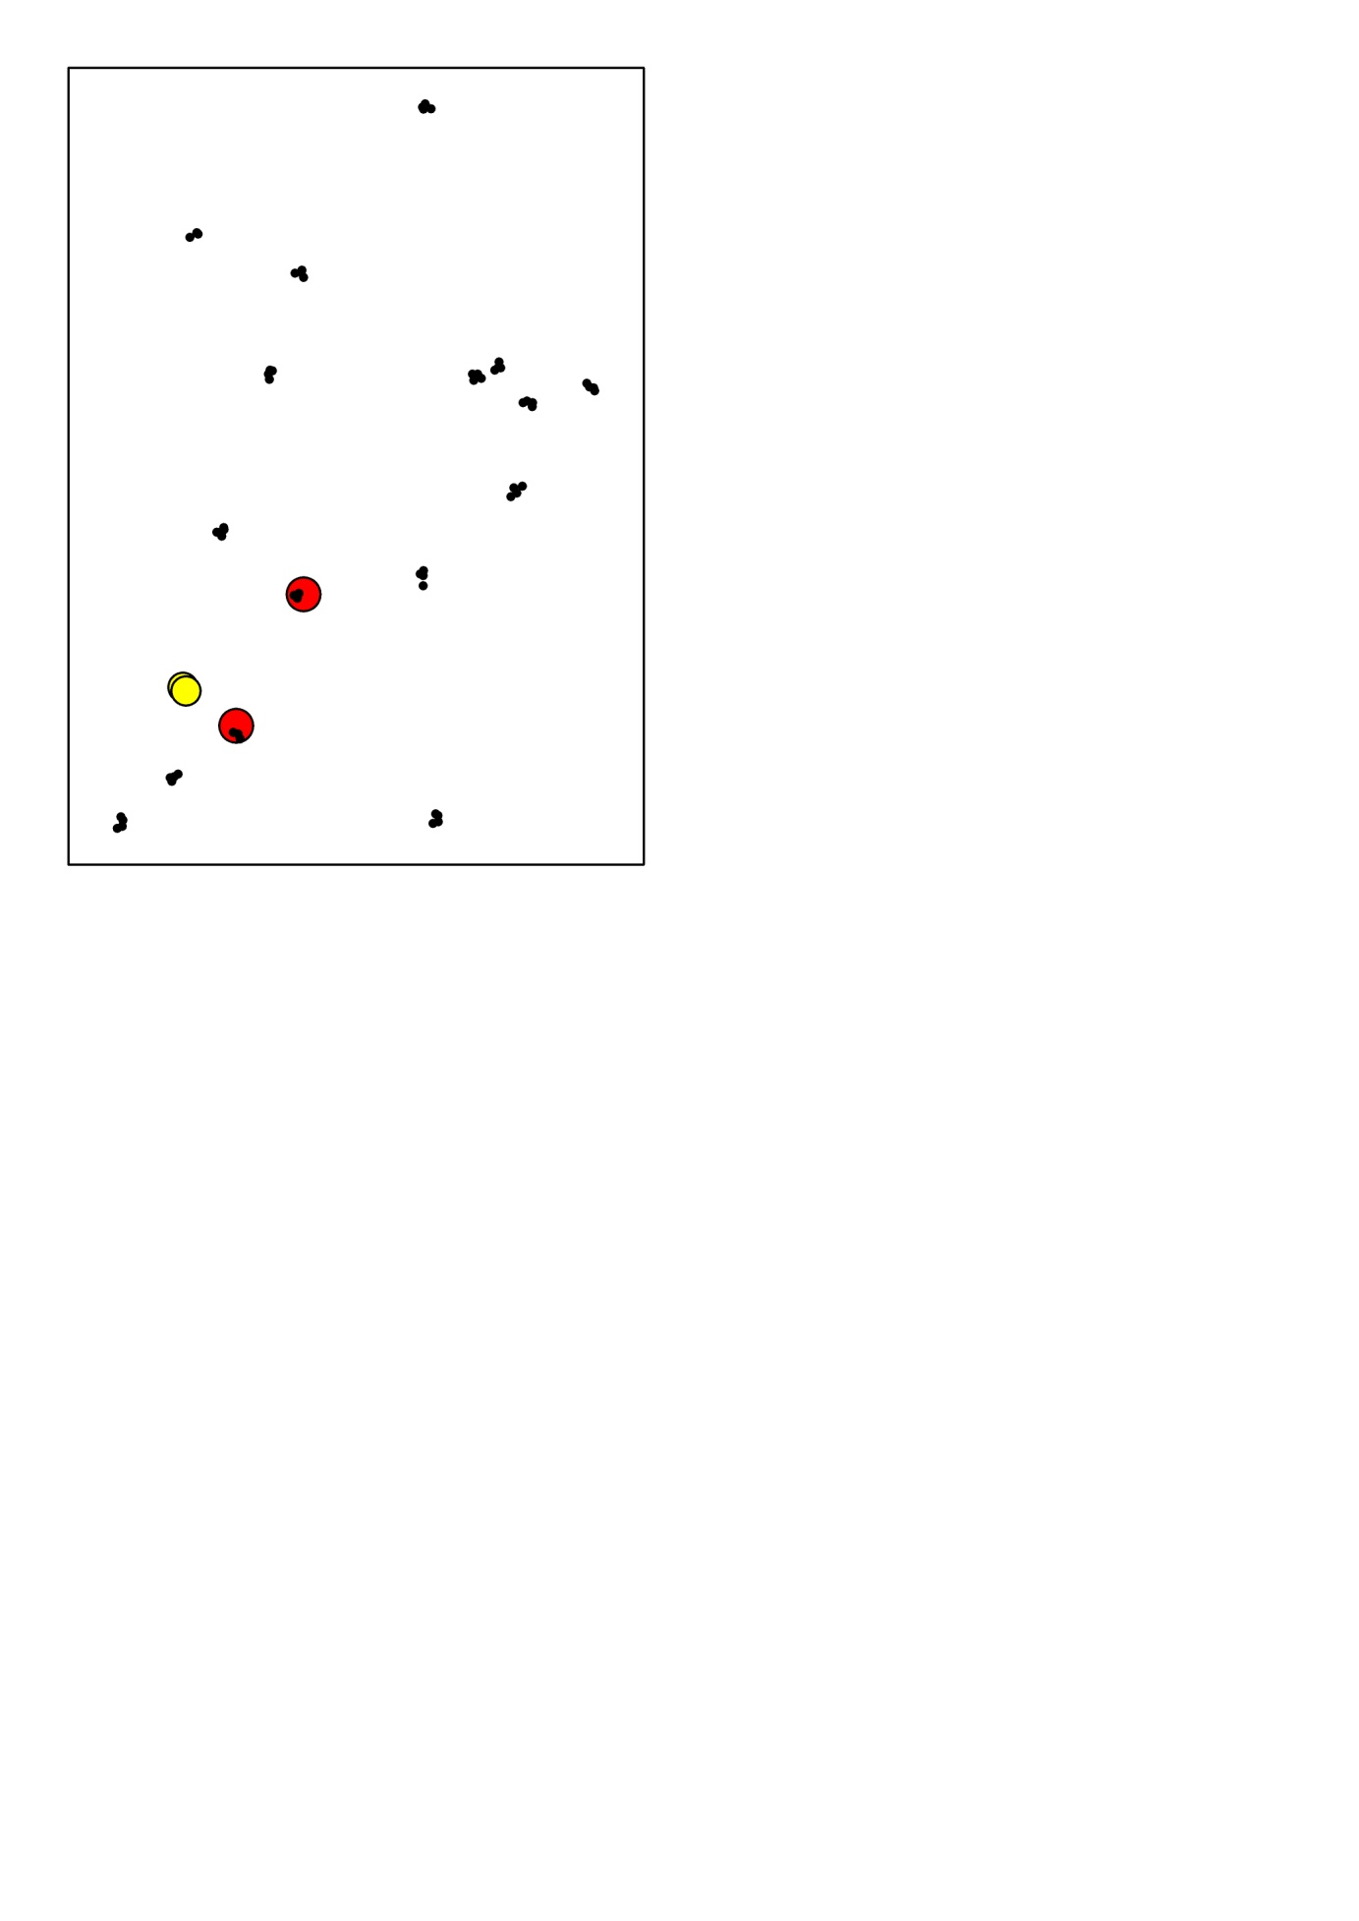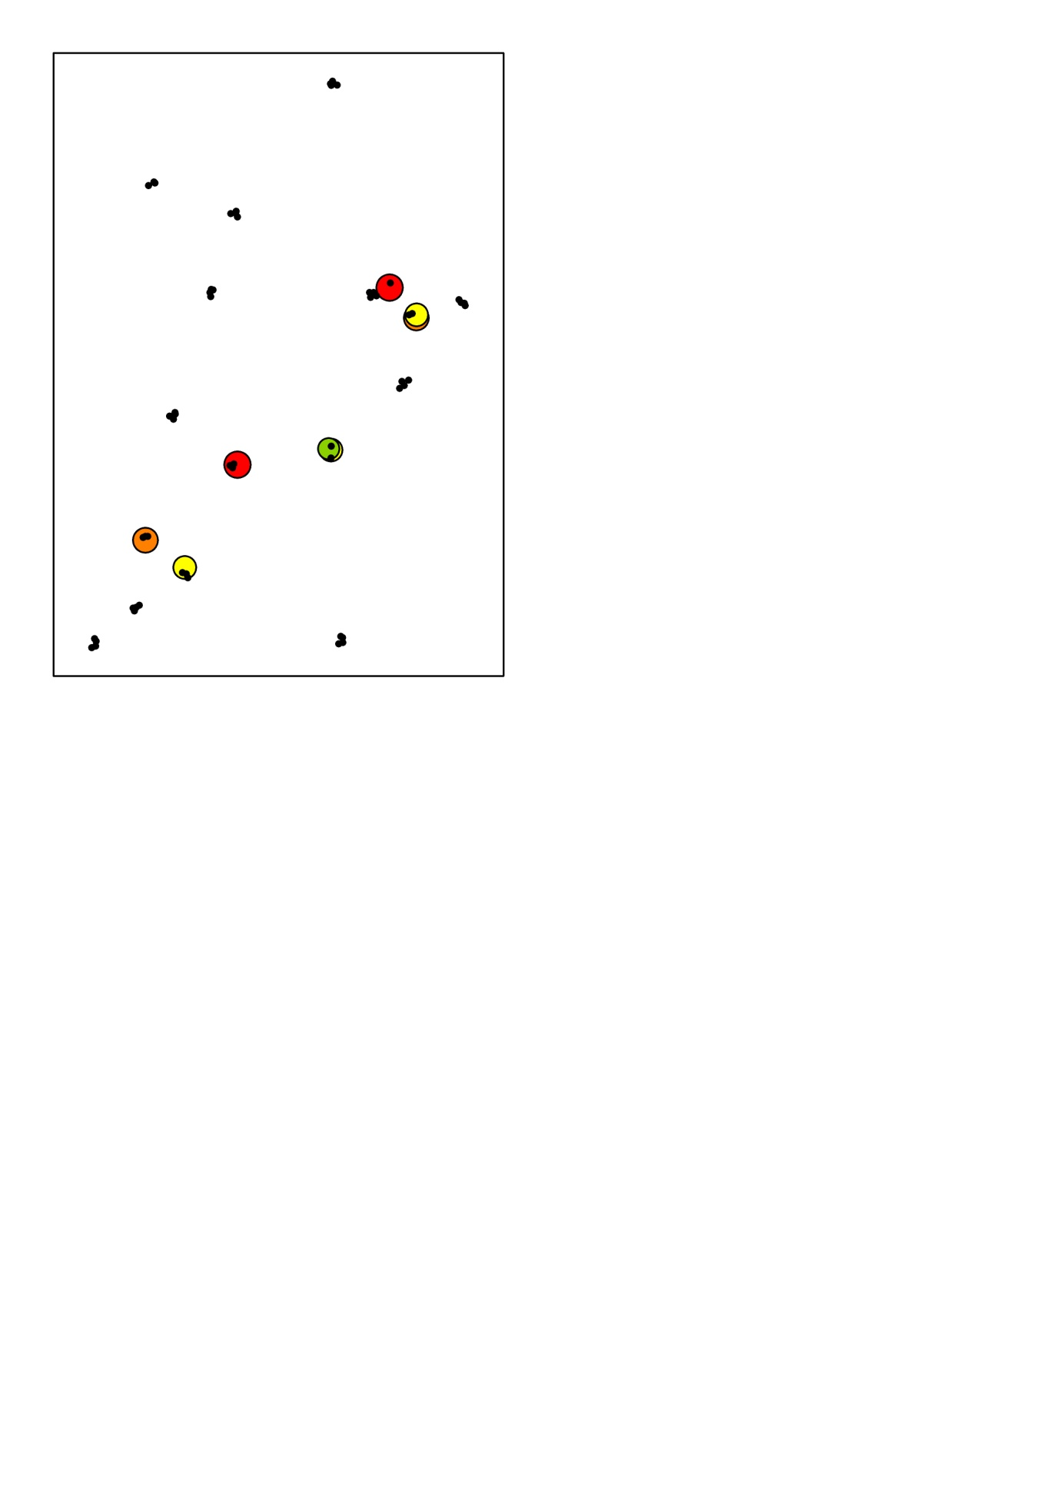

Season 3

Season 2

Season 1

Fig. S1b. Distribution of *Cs. annulata* in each season of 2010



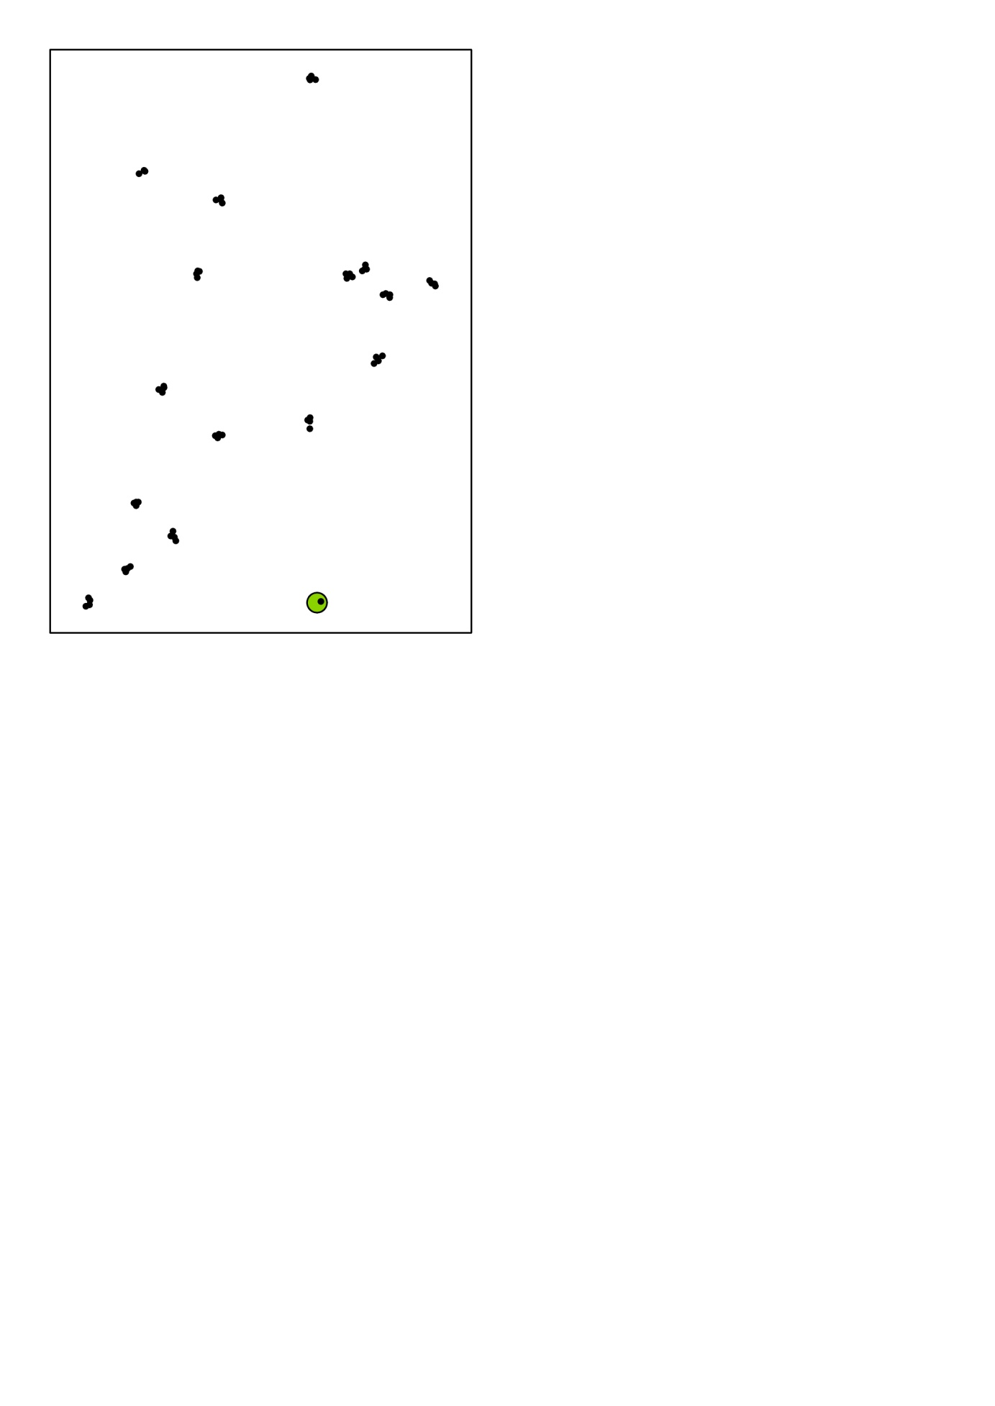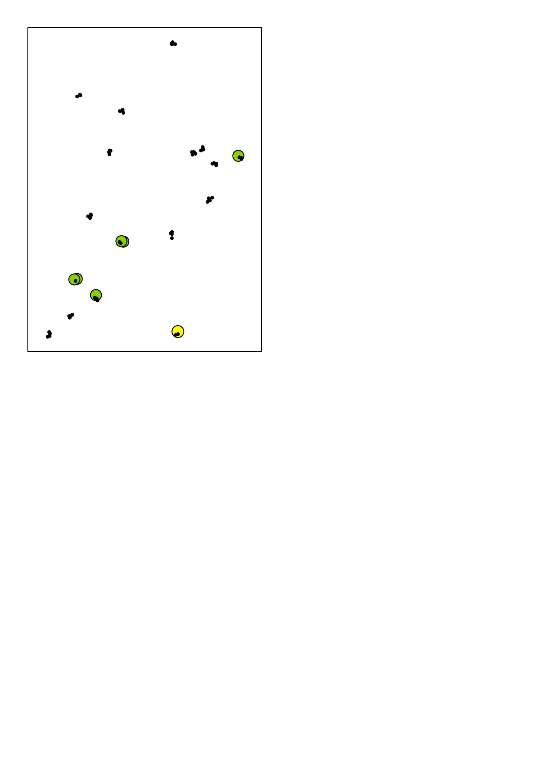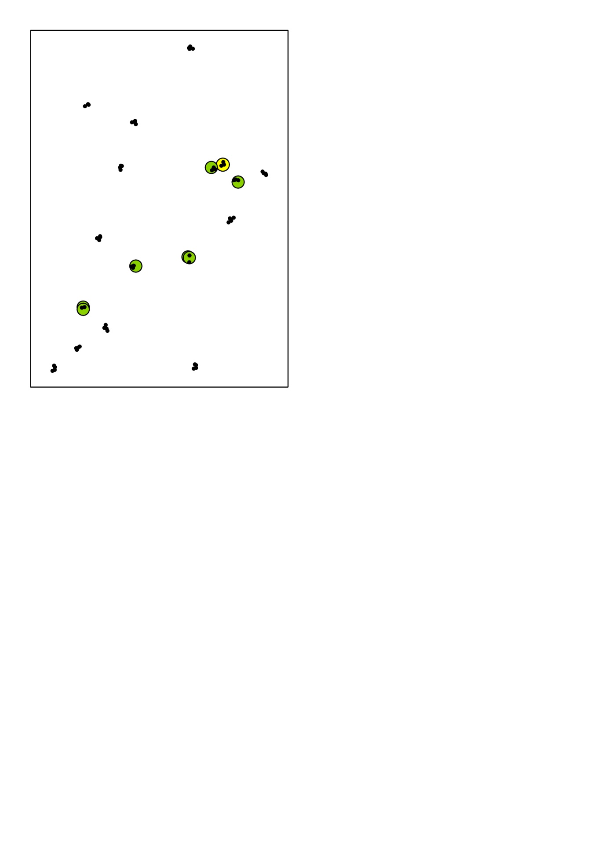

Season 3

Season 2

Season 1

Fig. S1c. Distribution of *An. claviger* in each season of 2010



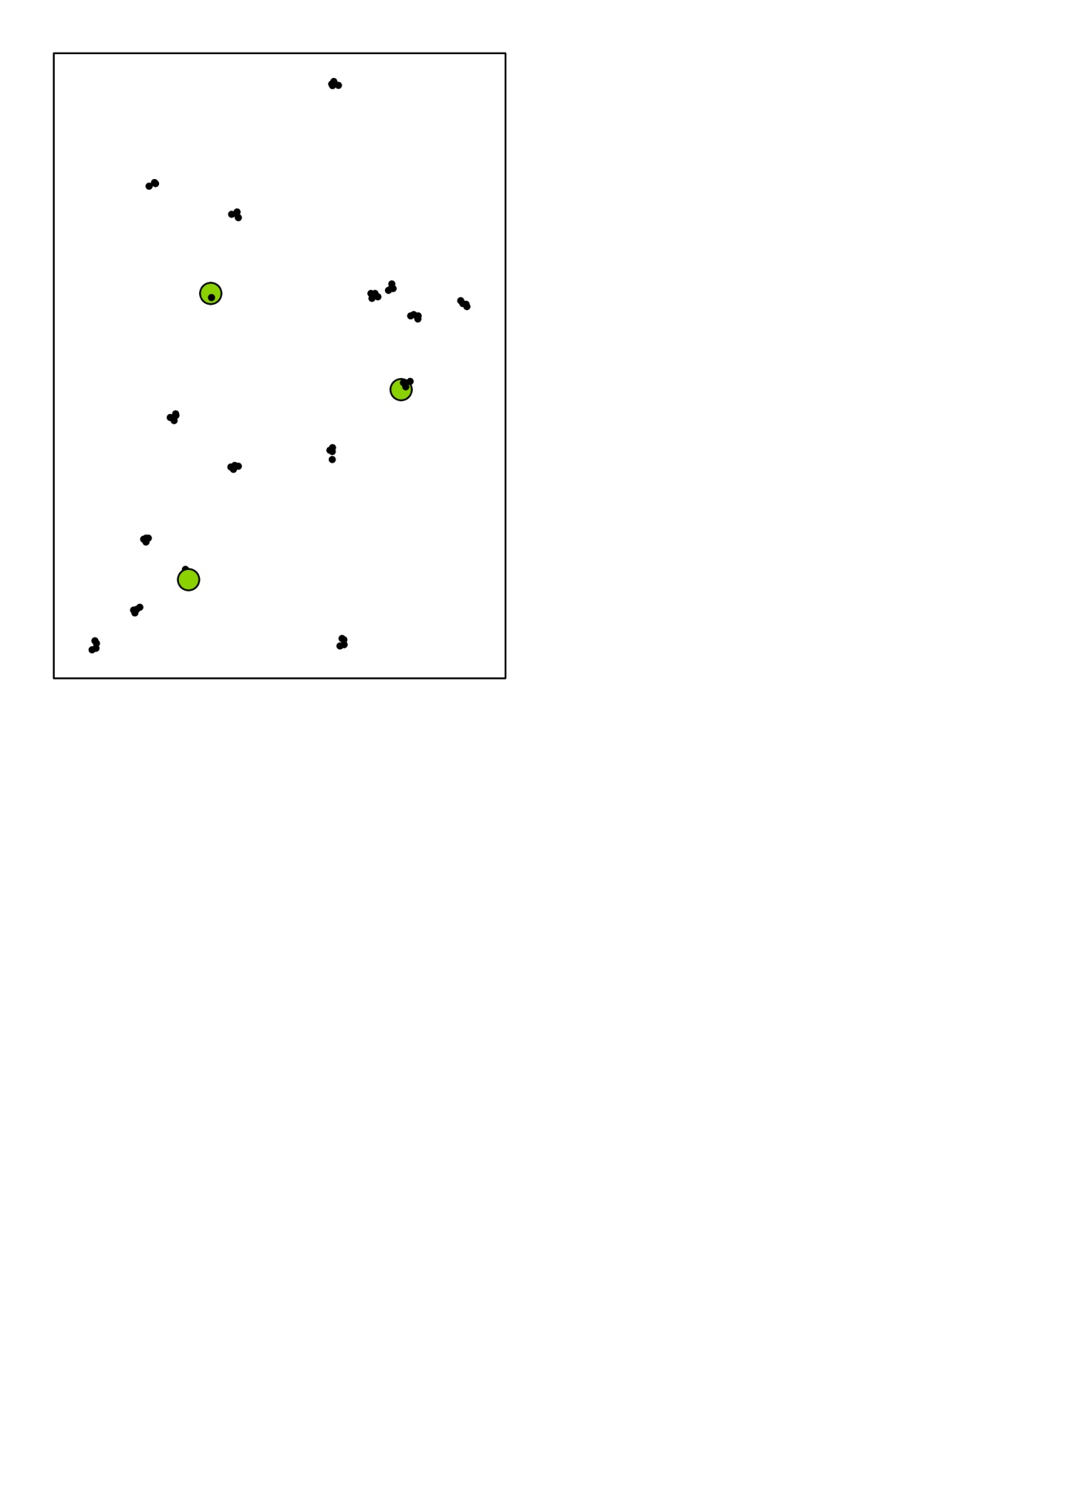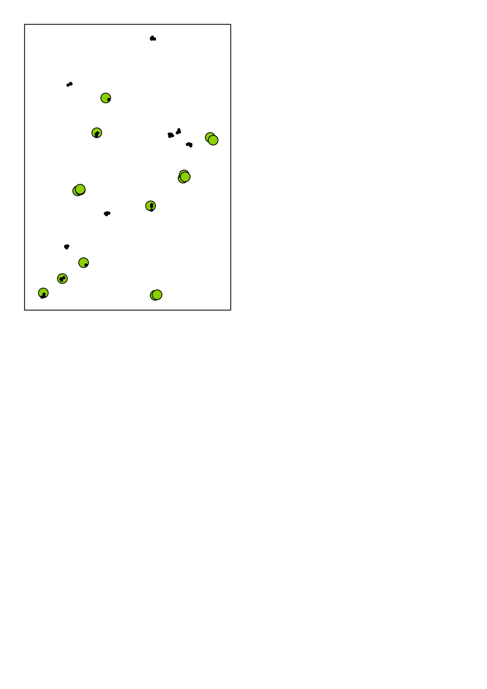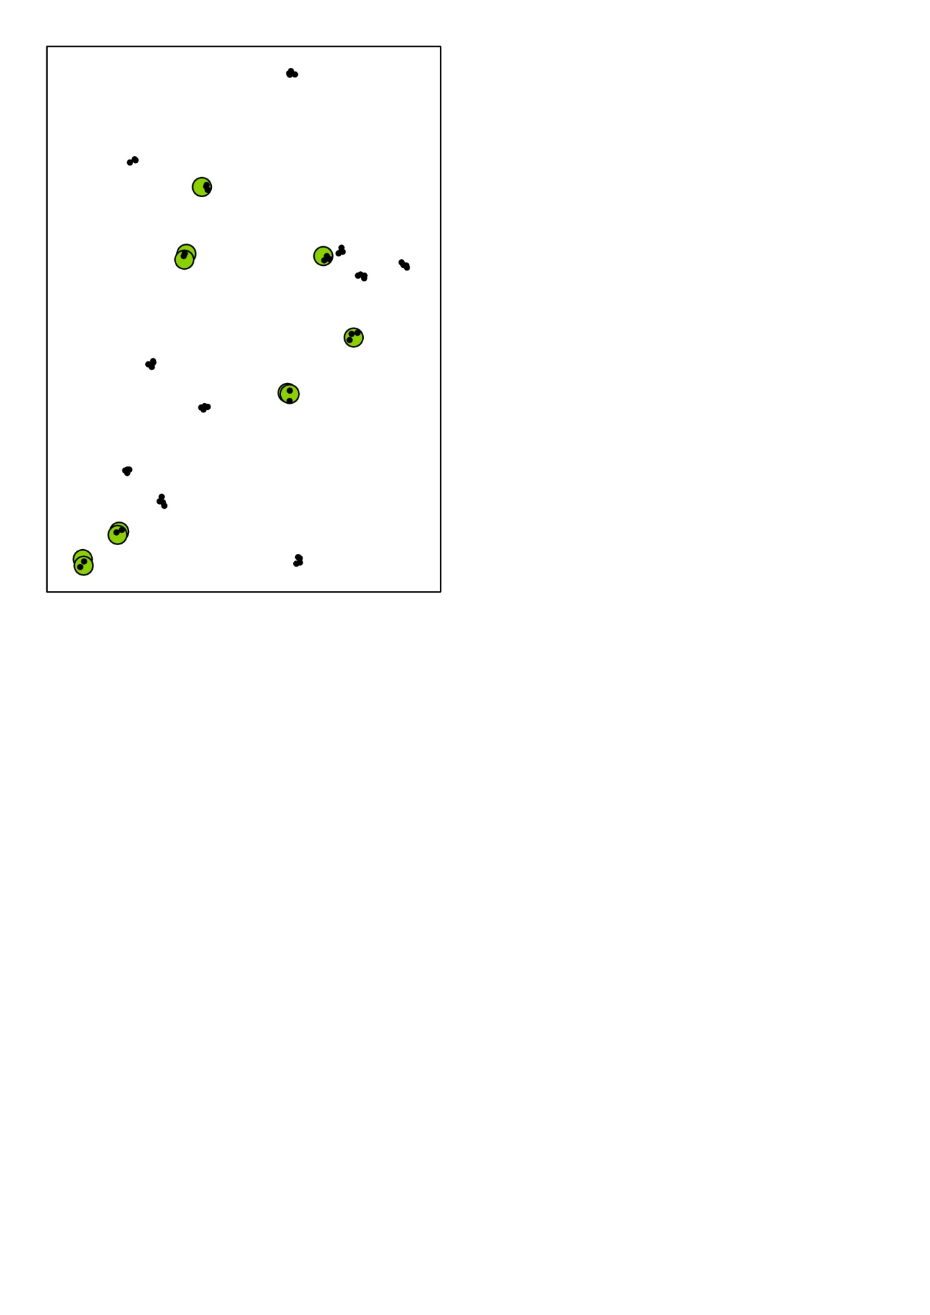

Fig. S1d. Distribution of *An. maculipennis* in each season of 2010

